**CS1101 – Programming Assignment 5**

**Student Name:** Merhawit Kahsay Gidey  
**Course:** CS1101 – Programming Fundamentals  
**Instructor:** Henry hu  
**Date:** Jul 20, 2025

In this assignment I will demonstrate the use of fundamental string operations and iterations in Python. Specifically, the program collects a user's name and performs three tasks:

1. Displays the first n characters from the left
2. Counts the number of vowels in the name
3. Prints the name in reverse.

These tasks utilize string indexing, slicing, iteration, and basic input/output functions.

**Explanation of Output and Code**

The program begins by asking the user to enter their name using the input() function. The entered name is stored in the variable name.

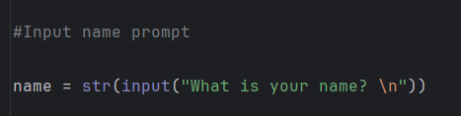

**1. Display *n* Characters from Left**

The function display_name() takes the name as a parameter and asks the user to enter the number of characters (*n*) they want to display from the left side of their name. It then uses string slicing (name[0:n]) to extract and print those characters. However, the use of a for loop with display_character -= 1 inside the loop doesn't produce multiple outputs with decreasing character count. Instead, it prints the same sliced string multiple times.

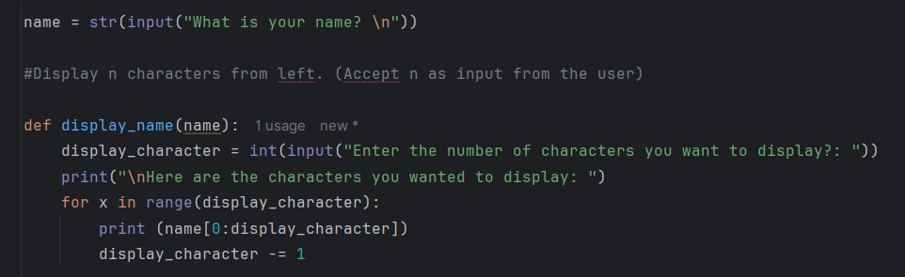

**2. Count Number of Vowels**

The count_vowels() function checks how many vowels appear in the name. A list of vowels (['a', 'e', 'i', 'o', 'u', 'y']) is defined. The name string is converted to lowercase to ensure case-insensitive matching. The function iterates through each vowel and checks if it is present in the name. If a match is found, the count is incremented by 1. This method checks for the presence of vowels but not their frequency.

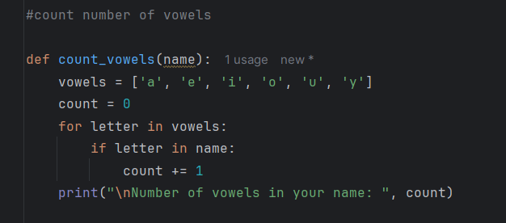

**3. Reverse the Name**

The reverse() function uses Python's slicing technique [::-1] to reverse the entire string and display it. This is a simple and effective way to reverse any string in Python.

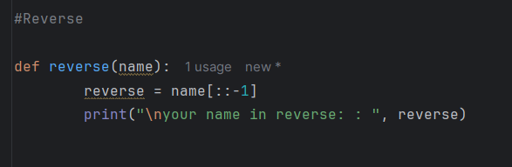

Calling the functions:

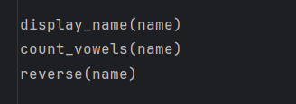

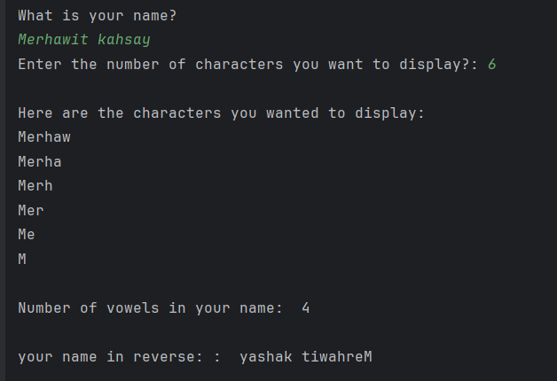#Output

This assignment reinforces fundamental concepts of string manipulation in Python, particularly string slicing, iteration, and the use of built-in functions like input() and print(). Additionally, it shows how to structure and call functions. Understanding these concepts is essential for more complex data processing tasks in Python programming.

**Reference**

Downey, A. (2015). *Think Python: How to Think Like a Computer Scientist* (2nd ed.). Green Tea Press.Retrieved from <http://greenteapress.com/thinkpython2/thinkpython2.pdf>